**KENDRIYA VIDYALAYA TAMENGLONG**

**CLASS- III F.A-III (2015-16) SUB : EVS**

**NAME : ……………………………… ROLL NO: ………… MARKS : 60**

**DATE : …………………………… TIME : 90 MIN.**

|  |  |  |  |  |
| --- | --- | --- | --- | --- |
| **COMPETENCY** | **OBSERVATION & REPORTING(10)** | **IDENTIFICATION**  **& CLASSIFICATION(15)** | **DISCOVERY OF FACTS**  **(15)** | **TOTAL**  **(40)** |
| **MARKS** |  |  |  |  |
| **GRADES** |  |  |  |  |

**INVIGILATOR’S SIGNATURE EXAMINER’S SIGNATURE**

**OBSERVATION AND REPORTING**

1. Observe the pictures and answer the question that follow:
2. Who is in the picture? What is he doing?

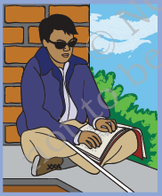

1. Whose picture is this? What are they making?

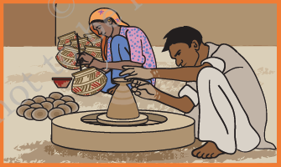

1. What game are the children playing?

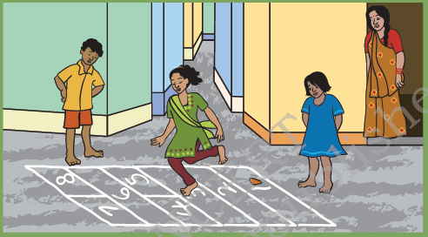

1. What do you see in the picture?

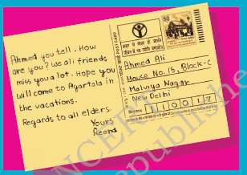

1. What does the picture show? Where is it found?

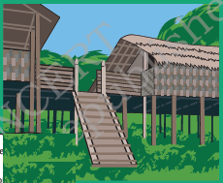

1. Read the following list and write the appropriate word against each.

Spinach Banana Pitcher Hospital

Snake and Ladder Igloo Telephone

* 1. Leafy vegetable : ___________________________
  2. To speak to a friend in America : ___________________________
  3. An indoor game : ___________________________
  4. A fruit : ___________________________
  5. Made of clay : ___________________________
  6. A snow house : ___________________________

**IDENTIFICATION & CLASSIFICATION**

1. Match the words in Column ‘A’ with words in Column ‘B’.

|  |  |  |
| --- | --- | --- |
| **Column: A** |  | **Column: B** |
| High buildings |  | Delhi |
|  |  |  |
| Roofs of thorny bushes |  | Dal Lake |
|  |  |  |
| House boat |  | Assam |
|  |  |  |
| House on bamboo pillars |  | Rajasthan |
|  |  |  |

Q.4 Fill in the boxes:-

1. We post our letter in it.

|  |  |  |  |  |  |  |
| --- | --- | --- | --- | --- | --- | --- |
|  |  |  |  |  |  |  |

2. Postman delivers.

|  |  |  |  |  |  |
| --- | --- | --- | --- | --- | --- |
|  |  |  |  |  |  |

3. Affixed it on parcel.

|  |  |  |  |  |
| --- | --- | --- | --- | --- |
|  |  |  |  |  |

4. Money is sent by it.

|  |  |  |  |  |  |  |  |  |  |
| --- | --- | --- | --- | --- | --- | --- | --- | --- | --- |
|  |  |  |  |  |  |  |  |  |  |

5. Letter is put in it to be posted.

|  |  |  |  |  |  |  |  |
| --- | --- | --- | --- | --- | --- | --- | --- |
|  |  |  |  |  |  |  |  |

Q.5 Draw the picture of your house and colour it.

Q.6 Why do we need a house ?

Ans. __________________________________________________________________________

_______________________________________________________________________________

|  |  |  |
| --- | --- | --- |
|  |  |  |
|  |  |  |

**DISCOVERY OF FACTS**

1. Put a ‘✓’ mark on the correct and ‘X’ mark on the wrong statement.
2. Family members often live together in the same house. ( )
3. We get turmeric from plant. ( )
4. Kho – Kho is an indoor game. ( )
5. Marker (thippi) is used to play football. ( )
6. Mint is used to cure cough and cold. ( )
7. Do as directed.
8. Write the names of four outdoor games.

Ans. _____________________________________________________________________

_________________________________________________________________________

1. Write the names of four food items that we get from plants.

Ans.___________________________________________________________________________________________________________________________________________________

1. What things are necessary to make a pot?

Ans._________________________________________________________________________________________________________________________________________________

1. 9 What is Braille Script?

Ans. ________________________________________________________________

________________________________________________________________

Q.10 Name different types of pots made of clay .

Ans. ________________________________________________________________

____________________________________________________________________

**KENDRIYA VIDYALAYA TAMENGLONG**

**CLASS- V F.A-III(2015-16) SUB : EVS**

**NAME : …………………………… ROLL NO: ………… MARKS : 60**

**DATE : …………………………… TIME : 1:30**

|  |  |  |  |  |
| --- | --- | --- | --- | --- |
| **COMPETENCY** | **OBSERVATION & REPORTING(10)** | **IDENTIFICATION**  **& CLASSIFICATION(15)** | **DISCOVERY OF FACTS**  **(15)** | **TOTAL**  **(40)** |
| **MARKS** |  |  |  |  |
| **GRADES** |  |  |  |  |

**INVIGILATOR’S SIGNATURE EXAMINER’S SIGNATURE**

**OBSERVATION & REPORTING**

I. Observe the following pictures and answer the questions.

From which natural calamity does the boy try to save

his life?

Ans : _________________________________



The girl tries to ______________ her hands by

blowing air.

 What is she doing ?

Ans : ________________________

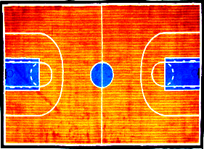

Name this court : ___________________________

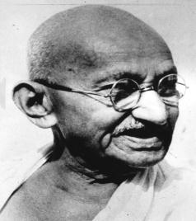 Name this person : ___________________________

Q.2 Why do people do different kinds of jobs ?

Ans: _______________________________________________________________________

_________________________________________________________________________

Q.3 How far is Mumbai from Delhi ?

Ans: _________________________________________________________________

Q. 4 What is refinery ?

Ans: ____________________________________________________________________

________________________________________________________________________

**IDENTIFICATION& CLASSIFICATION**

I. Choose the best answer and fill in the blanks.

1. Vehicles stop at the __________________ for filling fuel.

a) bus stop b) market c) petrol pump d) depot

2. You can find cold desert in ______________________.

a) Rajasthan b) Leh c) Abu Dhabi d) Tamilnadu

3. ______________ is a water related natural calamity.

a) earthquake b) forest fire c) flood d) tornado

4. ­­­­­­_________________­­­­­­­­­­­___ is an instrument used to listen our heartbeat.

a) microscope b) telescope c) stethoscope d) horoscope

5. _________ air is heavy and comes down.

a) Warmb) Coldc) Hot d) Heavy

Q.2 Write the names of outdoor games?

Ans: _________________________________________________________________

_______________________________________________________________________

Q.3 Write the name of different kinds of house and draw one picture of a house.

Ans: _______________________

___________________________

___________________________  
___________________________  
___________________________

Q. 4 What is a stethoscope ? Draw the picture of a stethoscope .

Ans: _____________________________

_________________________________

_________________________________

_________________________________

**DISCOVERY OF FACTS**

Q.5 Write the full forms:

1. L.P.G. _________________________________

Q. Name two instruments we blow air into to produce sound .

Ans: _______________________________________________________________________

Q.6 Find out the meaning of :

Seismograph ___________________________________________________________

7 write the serial numbers to show the journey of petrol .

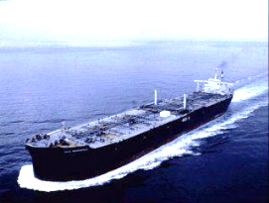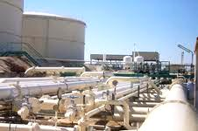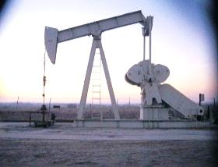

Petroleum oil Petrol Depot Transportation

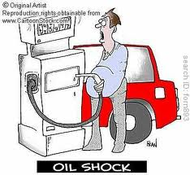

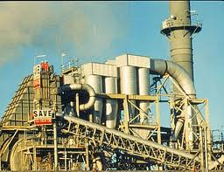

Refinery/ Processed Petrol pump

Q.8 What happened on 26 january, 2001?

Ans: ______________________________________________________________________

__________________________________________________________________________

__________________________________________________________________________

Q.9 Write the names of four natural diasasters .

Ans: ______________________

___________________________

____________________________

____________________________

Q.10 Write the national games of :

(1) India ________________________

(2) Australia _____________________

(3) England ______________________

**11**Read the bar chart carefully and answer the questions.

1. In year 1976, out of 100 how many houses used uple and wood ?

Ans : ____________________________________________________________

2. Which was the fuel used the least in 1976 ?

Ans : ____________________________________________________________

3. In 1976, LPG and kerosene were used in __________ houses and in 1996 this increased to _______________ .

4. Out of 100 how many houses were using electricity in 1996 ?

Ans : ____________________________________________________________

5. Which fuel was used the least in 1996 ?

Ans : ____________________________________________________________